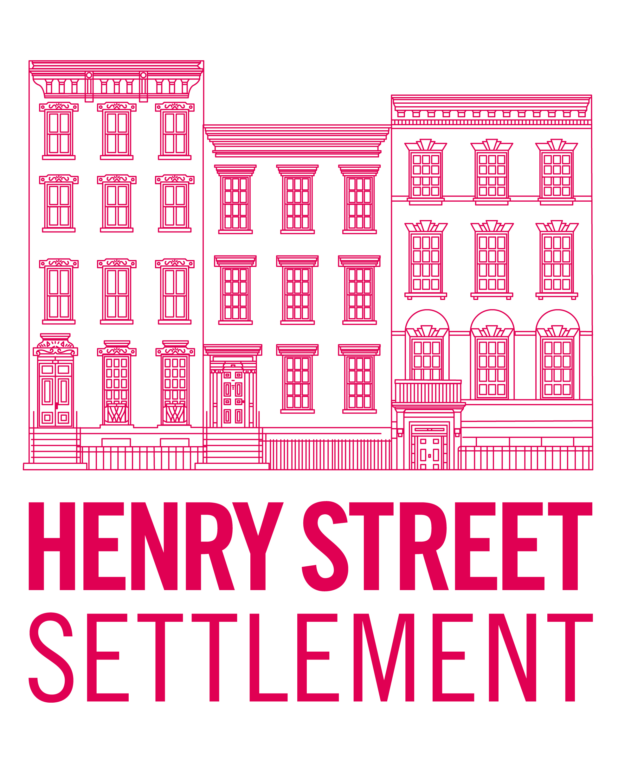

After-School at Manhattan Charter School
Application: School Year 2017-2018

PROGRAM INFORAMTION.

The Henry Street Settlement After-School Department is thrilled to operate an after-school program
for 60 Students at Manhattan Charter School I & II for the 2017-18 School Year. Henry Street’s After-
School team has over 100 years of collective experience providing outstanding after-school services.
We operate within a 3 cycle theme. Cycle 1: September to December- Citizen Explorers; Cycle 2: January to March- Innovative Scholars; and Cycle 3: March to June- Active Futurist. HSS offers an array of quality-driven educational, enrichment and recreational activities, and also strives to enhance academic success through parent programs and referrals to other supportive services. We reinforce family relationships and the social values of self-confidence, self-expression, positive peer relationships, responsible behavior and a social commitment to contribute to one's community.

We are offering a fee based program with a standard program rate of $75 a week per child. The program will begin on September 5, 2017 and end on in June 8, 2018. Our hours of operation are 3:30pm—
6:00pm, Monday—Friday. Services for pre-determined half-days will be available for an additional cost.

Standard Program Rates:

- $75.00/week per child
- $10.00/ per half-day (enrolled children)
- $20.00/per half-day (non-enrolled children, must complete mandatory paperwork)
- $5.00/per half-day (per non-enrolled child’s sibling, must complete mandatory paperwork)

Financial Aid:
The Henry Street Settlement offers programs and services to the community at subsidized rates. Limited financial assistance is available for program participants who otherwise would not be able to afford enrollment. A registrant may apply for financial assistance by filling out the Tuition Assistance Request
form, and returning it with your program registration form to the registrar. All applicants requesting
financial assistance must meet with a staff member from the After-School department prior to receiving
any award notification. The registrant’s parent’s most recent federal income tax return is required along
with the application. Registrants will be notified in writing regarding their financial assistance award and payment terms.

PARTICIPANT BACKGROUND
1

Primary Parent / Guardian of Participant:

Phone number:
Secondary Parent/ Guardian of Participant
Phone number (2): Email Address:

Date
Program
Year
2017-18

Last Name First Name
participant contact information

Home Address
Apartment Number

City State

Zip Code Borough

Home Phone
Email
Gender ◻ Female ◻ Male ◻ No Response
demographics

Date of Birth
Ethnicity | - Hispanic/Latino ◻ Not Hispanic/Latino  - No Response
Race | - American Indian or Alaskan Native ◻ Asian ◻ Black/African American  - Native Hawaiian/Pacific Islander ◻ White ◻ Other ◻ No Response
Country of Origin |  |  | Primary Language
English Proficient | - Yes ◻ No |  | Additional Language(s)
Student Status | Interested in half-day programming? |  | Yes or no: | - Yes ◻ No
 |  |  | Student ID / OSIS #
School Name |  |  | School Address
Teacher/ Advisor |  |  | Current Grade Level

Section 1. Participant Background (continued)
NAME |  | Relationship to Participant:
Pick Up | - This person may pick up my child. |  | Contact | Write down all numbers and circle the best number to call in case of an emergency:  - Home  - Cell  - Work  - Email
Address
Apartment
City, State
Zip Code

other family and household information | The participant lives in housing that is: (Check all that apply) ◻ Rental ◻ Family Owned ◻ NYCHA housing OR The participant is: ◻ Homeless ◻ Other:
 | Is or has the participant ever been in foster care: |  |  |  | - Yes ◻ No
 | Has the participant been enrolled in programs operated by the Administration for Children’s Services (ACS)? |  |  |  | - Yes | - No
 | Is the participant or any member of the household (0-64 years old) covered by Medicaid, Child Health Plus, Family Health Plus, or private health insurance? |  |  |  | - Yes | - No
 | If you answered no to the previous question, would you like to be contacted by someone for assistance with health insurance? |  |  |  | - Yes | - No
 | Number of individuals in your household:
 | * Is the participant or any member of your household receiving public assistance? |  |  |  | - Yes | - No
 | * Is the participant or any member of your household receiving food stamps? |  |  |  | - Yes | - No
 | * Gross Yearly Household Income: |  |  |  | $
 | The participant lives in a household that is headed by: | - Self, Single, no children | - Single Female Parent  - Single Male Parent | - Two Parents  - Two Adults, no children
 | * Sources of household income:  - Employment  - Pension | - TANF  - SSI | - Social Security  - General Assistance | - Unemployment Insurance  - Other

PARTICIPANT SAFETYPlease place parent info in the emergency contact boxes if applicable.

EMERGENCY CONTACTS. If there is an emergency, please contact the following individuals:
NAME |  |  | Relationship to Participant:
Pick Up | - This person may pick up my child. |  | Contact | Write down all numbers and circle the best number to call in case of an emergency:  - Home  - Cell  - Work  - Email
Address
Apartment
City, State
Zip Code



PARTICIPANT SAFETY
Section 2. Participant Safety (continued)

PARTICIPANT HEALTH INFORMATION.
Please attach a copy of recent/valid insurance card.
Please check any of the following that pertain to the participant. Many needs or health challenges can be accommodated and may not limit enrollment in the program.

- Allergies to food | - Behavioral/Emotional Issues | - Diabetes | - Obesity
- Allergies to medications | - Convulsions/Seizures | - Medication | - Physical Disabilities
- Asthma* | - Congestive Illness (e.g., heart murmur/disease, blood pressure) | - Corrective Devices (e.g., crutches, hearing aid, eye glasses) | - Pregnancy
If you have checked any of the above OR there are other important health needs that may affect participation in the program, including activities that the participant MAY NOT do, please provide details:
*Please attach updated Asthma Action Plan. (Can be obtained by Child's Primary Care Provider.)

PICK UP/DISMISSAL INFORMATION.
My child MAY NOT be picked up by:

The following individuals are authorized to pick up my child:
NAME |  | Relationship to Participant
Write down all phone numbers and circle the best number to call in case of an emergency:
Phone ◻ Home ◻ Cell
- Work ◻ Other

Email Address:

NAME |  | Relationship to Participant
Write down all phone numbers and circle the best number to call in case of an emergency:
Phone ◻ Home ◻ Cell
- Work ◻ Other

Email Address:

Place parent information above only if it was not already placed in emergency contact info.

PARTICIPANT INTERESTS.

Interests/Activities | Likes/Strengths |  Dislikes/Challenges
Reading
Math
Media (digital art, photography, videography)
Writing(poetry, short fiction, journaling)
Art (painting, drawing, sculpturing)
Performance (music, dance, drama)
Science Technology Engineering Math/STEM
Sports (team, individual)
Video Games
Board Games
Cooking & Nutrition
Gardening

How we can be helpful to you/your child? Are there are other services or activities that would be interesting and or helpful to you/your child? Does your child have an Individualized Education Plan and/or Special Needs? ◻ Yes ◻ No
Please use the space below or on the back of the page to provide details or list goals you would like to share with us.

OTHER SERVICES.
*Please check any other DYCD services you or your family might be interested in learning more about?

⁭⁭Δ Education/Literacy/High
Δ School Equivalency
⁭Δ Adolescent Literacy
⁭Δ Fatherhood Services
⁭Δ Housing Assistance
⁭Δ Immigrant Services
⁭Δ LGBTQ Support Services
⁭Δ Runaway/Homeless Youth
⁭Δ Senior Services
⁭⁭Δ Summer Youth Employment
⁭Δ Young Adult Internships
⁭ΔWorkshops/Fairs

SIGNATURES.

To the best of my knowledge the information above is true. I agree to its verification and understand that falsification may be grounds for termination of service. Information provided may be used by the City of New York to improve City services or to access additional funding.

I have completed this application for my child.
Parent/Guardian:
(Print) (Sign) (Date)

I have completed this application for myself.

Applicant: (18 and older)
N/A N/A N/A

(Print) (Sign) (Date)

Organization: Henry Street Settlement

Intake Specialist/Staff:
Date:

Henry Street Settlement After-School and Camp Services
HENRY STREET SETTLEMENT
Division of Youth Services 301 Henry Street
New York, NY 10002 (P) 212-254-3100
(F) 212-777-1445

Additional Pick-up/Emergency Contacts List (not required)

Participants Name: _____________________________________________ Date of Birth: _______________

Name: | Relationship:
Phone Number: ( ) - Type: □ Home □ Work □ Cellphone □ Other
Phone Number: ( ) - Type: □ Home □ Work □ Cellphone □ Other
Is this person an Emergency Contact: □ YES □ NO | Is this person authorized to pick up: □ YES □ NO
Email Address:
Language Spoken: □ English □ Spanish □ Mandarin □ Cantonese □ Other - Please Specify: ________________

Name: | Relationship:
Phone Number: ( ) - Type: □ Home □ Work □ Cellphone □ Other
Phone Number: ( ) - Type: □ Home □ Work □ Cellphone □ Other
Is this person an Emergency Contact: □ YES □ NO | Is this person authorized to pick up: □ YES □ NO
Email Address:
Language Spoken: □ English □ Spanish □ Mandarin □ Cantonese □ Other - Please Specify: ________________

Name: | Relationship:
Phone Number: ( ) - Type: □ Home □ Work □ Cellphone □ Other
Phone Number: ( ) - Type: □ Home □ Work □ Cellphone □ Other
Is this person an Emergency Contact: □ YES □ NO | Is this person authorized to pick up: □ YES □ NO
Email Address:
Language Spoken: □ English □ Spanish □ Mandarin □ Cantonese □ Other - Please Specify: ________________

CHILD MAY NOT BE PICKED UP BY | RELATIONSHIP OF THE PERSON NOT ALLOWED

Program Enrollment Packet  page 6

Walking Permission
HENRY STREET SETTLEMENT
Division of Youth Services 301 Henry Street
New York, NY 10002 (P) 212-254-3100
(F) 212-777-1445

I give my permission for Henry Street Settlement staff to take my child on walking field trips as a part of their After-School / Summer Day Camp activities. This includes, but is not limited to: neighborhood parks, Abrons Arts Center, events at other public places, after- school programs-Manhattan Charter School I & II, 301 Henry Street, PS110, PS134, PS20, and BGR- etc. I understand that for any field trip involving transportation, I will receive a permission slip specific to that particular trip.
(Check One) Yes No

Parent/ Legal Guardian Signature Date

Educational Evaluation Permission
I give consent for staff from Henry Street Settlement to contact my child’s school and obtain records showing their progress, including information about grades, citywide and state test scores, attendance, and behavior.
(Check One) Yes No

Parent/ Legal Guardian Signature Date

Life Skills/ Therapeutic Services Permission
Occasionally Henry Street is fortunate to have Social Work interns to assist children through individual crisis management sessions, counseling sessions or group “Life Skills” sessions. By signing below, I do hereby give my child permission to participate in these sessions.
“Life Skills” is a series of group session that will be facilitated by a Henry Street Settlement Masters Level Social Work intern. The curriculum is designed to help your child build personal strengths and self- esteem, work through conflicts and learn how to resist pressures to engage in risky behaviors. This is a prevention program in which all students are strongly encouraged to participate.
Your child may be a member of a group of 8-10 girls or boys that may meet on a weekly basis. The sessions may address the following topic

Media Messages Health and Nutrition
Conflict Resolution Identifying & Avoiding Risky Behavior
Peer Pressure & Refusal Self-Esteem & Establishing a Positive Mindset
In the event that your child is selected for “Life Skills” you will be reminded again through a letter and you have the right to review all of the materials used in the “Life Skills” curriculum and that I have the right to revoke this permission at any time.
My child has my permission to participate. YES NO (circle one)

Parent/Guardian signature

Photo/Video/Interview Permission
Date

I understand that this after-school/camp program features special events both in-school and away from school. Media representatives, newspaper and television reporters, photographers, and public-relations personnel may be present at these special events to record them. In some cases they may interview and/or photograph children who participate in these events. These photographs, videos, and interviews will only be used to promote this after-school/camp program. I give permission for my child to be photographed or otherwise recorded during after-school/camp events and activities, and for any and all such photographs to be displayed by Henry Street Settlement in any medium (books, newsletters, web sites, etc.), whether now or hereafter known or developed.

(Check One) Yes No
Parent/Guardian signature Date

Henry Street Settlement After-School and Camp Services
HENRY STREET SETTLEMENT
Division of Youth Services 301 Henry Street
New York, NY 10002 (P) 212-254-3100
(F) 212-777-1445

Code of Conduct and Homework Agreement

As a member of the Henry Street Settlement After-School Programs, I pledge that I will:

Follow the rules as stated in the handbook; as well as the rules set by program staff.
- Be prepared each day with my homework, pencils, notebooks and at least 1 book to read.
- Respect the rights and property of other students.
- Resolve conflicts peacefully without fighting or name-calling.
- Be respectful and courteous to all staff, parents and children of the program.
- Take proper care of all spaces we utilize, the contents of the room, and all property belonging to the Henry Street Settlement.
- Enjoy and appreciate the opportunity to be part of this program and to have fun and learn. Participant Signature: Date:

As a Parent/Guardian of a child in after-school, I agree to:

- Check my child's homework with him/her to make sure it is completed.
- Support my child with unfinished or difficult homework that may not have been completed.
- Talk with the program staff about homework or other related issues if necessary.
- Be on time every day to receive my child at dismissal time or designate another adult to do so. Parent/Guardian Signature: Date:

The After-School program staff agrees to:

- Provide a safe, nurturing and comfortable are to grow and develop.
- Guide and assist student with their homework and in their activities while allowing them space to grow and mature
- Communicate successes as well concerns about behavior and homework to families.
- Engage the students in fun, creative activities that will have a positive impact on them.

Staff Signature: Date:

CHILD & ADOLESCENT HEALTH EXAMINATION FORM
NYC DEPARTMENT OF HEALTH & MENTAL HYGIENE — DEPARTMENT OF EDUCATION

Asthma Action Plan
Name | Date
Doctor | Medical Record #
Doctor’s Office Phone #: Day Night/Weekend
Emergency Contact
Doctor’s Signature

The Colors of a traffic light will help you use your asthma medicines.
Green means Go Zone!
Use preventive medicine.
Yellow Means Caution Zone!
Add quick-relief medicine.
Red means Danger Zone!
Get help from a doctor.
Personal Best Peak Flow

GO Use these daily preventive anti-inflammatory medicines:

You have all of these:
MEDICINE | HOW MUCH | HOW OFTEN/WHEN

- Breathing is good
- No cough or wheeze
- Sleep through the night
- Can work and play

Peak flow from
to

For asthma with exercise, take:

CAUTION
Continue with green zone medicine and add:
You have any of these:
MEDICINE | HOW MUCH | HOW OFTEN/WHEN

- First signs of a cold
- Exposure to known trigger
- Cough • Mild wheeze
- Tight chest • Coughing at night

Peak flow from
to

CALL YOUR PRIMARY CARE PROVIDER.

DANGER Take these medicines and call your doctor now.

Your asthma is getting worse fast:
MEDICINE | HOW MUCH | HOW OFTEN/WHEN

- Medicine is not helping
- Breathing is hard and fast
- Nose opens wide
- Ribs show
- Can’t talk well

Peak flow reading below

GET HELP FROM A DOCTOR NOW! Do not be afraid of causing a fuss. Your doctor will want to see you right away. It’s important! If you cannot contact your doctor, go directly to the emer- gency room. DO NOT WAIT.
Make an appointment with your primary care provider within two days of an ER visit or hospitalization.

State of New York, George E. Pataki, Governor
Department of Health, Antonia C. Novello, M.D., M.P.H., Dr.P.H., Commissioner

4850

