August |  |  | Henry Street Settlement  Virtual Senior Center  “Where Good Friends Meet”
Monday | Tuesday | Wednesday |  | Thursday |  | Friday
11:00 am: Art w/ Jia & Ace  Zoom Mtg ID: 892 5389 0895  Click here to Join Zoom Meeting!!  12:00 pm: Noon w/ Karina  Zoom Mtg ID: 898 8824 3711  Click Here to Join Zoom Meeting!!  1:00 Bingo W/Olivia NEW!!  Zoom Mtg ID: 874 8318 1329  Click Here To Join Zoom Meeting!!  Starting Monday 8/16!!  2:00 pm: “The Census 2020: Why & How” w/ Jing  Zoom Mtg ID: 810 6652 4506  Click Here To Join Zoom Meeting!! | 10:00 am: Morning Yoga w/ Jolie New!!  Zoom Mtg ID: 834 2114 4182  Click Here To Join Zoom Meeting!!  12:00 pm: NEW!!  “Farmers Market workshops” by EatingHealthyNYC  Zoom Mtg ID: 871 7219 6163  Click Here To Join Zoom Meeting!!  1:00 pm: Cooking w/ Ann  Zoom Mtg ID: 830 8892 0001  Click Here To Join Zoom Meeting!!  2:00 pm: Learn About Alzheimer’s Presentations  Zoom Mtg ID: 821 2118 6861  Click Here To Join Zoom Meeting!!  3:00 pm: Movement Speaks  Zoom Mtg ID: 882 9047 3486  Click Here To Join Zoom Meeting!! | 11:00 am: Voices of Ascension  Zoom Mtg ID: 834 0831 7629  Click Here To Join Zoom Meeting!!  12:00 pm: Dessert w/ Ann  Zoom Mtg ID: 830 6860 7168  Click Here To Join Zoom Meeting!!  1:00 pm: Simply Tai Chi w/David  Zoom Mtg ID: 895 2337 9243  Click Here To Join Zoom Meeting!!  2:00 pm: Be Flexible w/ Linda  Zoom Mtg ID: 858 7274 2853  Click Here To Join Zoom Meeting!!  3:00 pm: Art w/ Linda  Zoom Mtg ID: 819 7461 2024  Click Here To Join Zoom Meeting!! |  | 10:00 am: Life Story Workshop w/  Lily zhou from Vita Story Club NEW!!  Zoom Mtg ID: 848 3331 6664  Click Here To Join Zoom Meeting!!  12:00 am: Salud Holística  w/ Nurse Arthur (Spanish)  Zoom Mtg ID: 820 0645 2818  Click Here To Join Zoom Meeting!!  1:00 pm: Pet Visiting w/Amy  Zoom Mtg ID: 810 7727 0496  Click Here To Join Zoom Meeting!!  2:00 pm: Drawing w/ Will  Zoom Mtg ID: 812 1135 0510  Click Here To Join Zoom Meeting!!  3:00 pm Holistic Health w/ Nurse Arthur (English)  Zoom Mtg ID: 898 6066 4161  Click Here To Join Zoom Meeting!!  4:00 pm: Chinese Dance Group  Zoom Mtg ID: 816 6732 6275  Click Here To Join Zoom Class!! |  | 12:00pm: Meditation w/Daniela  Zoom Mtg ID: 867 7027 8089  Click Here to Join Zoom Meeting!!  1:00 pm: Zumba w/ Dream  Zoom Mtg ID: 869 1395 7452  Click Here To Join Zoom Meeting!!  2:00 pm: Chinese Dance  w/ Dream  Zoom Mtg ID: 837 4715 4778  Click Here To Join Zoom Meeting!!  3:00 pm: “Music Concert”  W/Olivia NEW!!  Zoom ID:834 9178 9152  Click Here To Join Zoom Meeting!!  MONTHLY EVENT!!  8/7 11:00 AM:  “Greenmarket At Home” by “GROW NYC”  Zoom Mtg ID: 831 7249 7878  Click Here To Join Zoom Meeting!!  (Every 1st Friday of the month)
SPECIAL EVENT!!  8/10 3:00 pm: Virtual Nutrition Workshop W/Brenna from Food Bank For NYC  Zoom Mtg ID: 836 1358 8003  Click Here To Join Zoom Meeting!!  SPECIAL EVENT!!  8/17 3:00pm Virtual Karaoke for everyone!! W/Karina  Zoom Mtg ID: 812 8573 4070  Click Here To Join Zoom Meeting!! | SPECIAL EVENT!!  8/11 11:00 am: Vocal Ease Concert!!  Zoom Mtg ID: 822 5918 4722  Click Here To Join Zoom Meeting!! | Partner Event  11:00 am: Betances Health Center “Nutrition Group”  Click Here To Join Meeting!! |  | SPECIAL EVENT!!  8/13 12:00 pm: “NYU School Of Dentistry” Dental Emergencies in the Covid-19 Pandemic  Zoom Mtg ID: 914 7860 0602 (Spanish)  Click Here To Join Zoom Class!!  Zoom Mtg ID: 944 0416 7175 (Cantonese)  Click Here To Join Zoom Class!!  SPECIAL EVENT!!  8/27 3:00 pm  Senior Birthday Party!!  w/ Olivia  Zoom Mtg ID: 884 2701 8730  Click Here to Join Zoom Meeting!! |  | No Smartphone?  :No Computer?  Call (929) 205-6099 & Enter the Class Code when Asked to Join Any Class  1st Time Joining Us?  Come a Bit Early so You Can Register
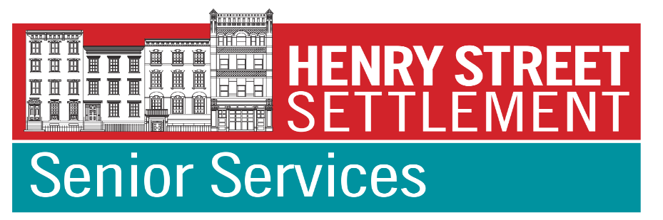 |  | Coming Soon:  More Virtual Classes  Plus Virtual Presentations, Trips, Tours & Performances  Funded by the NYC Department for the Aging & Henry Street Settlement |  |  | To register for virtual tours, trips or concerts,  be added to our member email list  or for more information, please contact us at VirtualSeniorCenter@henrystreet.org  or call 347-493-2787

