八月 |  |  | Henry Street Settlement  Virtual Senior Center  “Where Good Friends Meet”
星期一 | 星期二 | 星期三 |  | 星期四 |  | 星期五
11:00 am: 繪畫 w/ Jia & Ace  Zoom Mtg ID: 892 5389 0895  Click here to Join Zoom Meeting!!  12:00 pm: 中午閒聊 w/ Karina  Zoom Mtg ID: 898 8824 3711  Click Here to Join Zoom Meeting!!  1:00 pm: 賓果遊戲 W/Olivia 新活動!!  Zoom Mtg ID: 874 8318 1329  Click Here To Join Zoom Meeting!!  星期一開始 8/16!!  2:00 pm: “2020人口普查: 為什麼 及 如何” w/ Jing  Zoom Mtg ID: 810 6652 4506  Click Here To Join Zoom Meeting!! | 10:00 am: 早上瑜珈 w/ Jolie 新活動!!  Zoom Mtg ID: 834 2114 4182  Click Here To Join Zoom Meeting!!  12:00 pm: 新活動!!  “農產品（菜帣）工作坊” by EatingHealthyNYC  Zoom Mtg ID: 871 7219 6163  Click Here To Join Zoom Meeting!!  1:00 pm: 烹飪課 w/ Ann  Zoom Mtg ID: 830 8892 0001  Click Here To Join Zoom Meeting!!  2:00 pm: 認識阿茨海默症  Zoom Mtg ID: 821 2118 6861  Click Here To Join Zoom Meeting!!  3:00 pm: 一起動起來  Zoom Mtg ID: 882 9047 3486  Click Here To Join Zoom Meeting!! | 11:00 am: 唱詩班  Zoom Mtg ID: 834 0831 7629  Click Here To Join Zoom Meeting!!  12:00 pm: 甜點 w/ Ann  Zoom Mtg ID: 830 6860 7168  Click Here To Join Zoom Meeting!!  1:00 pm: 簡易太極 w/David  Zoom Mtg ID: 895 2337 9243  Click Here To Join Zoom Meeting!!  2:00 pm: 一起鍛鍊柔韌 w/ Linda  Zoom Mtg ID: 858 7274 2853  Click Here To Join Zoom Meeting!!  3:00 pm: 繪畫 w/ Linda  Zoom Mtg ID: 819 7461 2024  Click Here To Join Zoom Meeting!! |  | 10:00 am: 生命物語 工作坊 w/  Lily zhou（ Vita 故事俱樂部）新活動!!  Zoom Mtg ID: 848 3331 6664  Click Here To Join Zoom Meeting!!  12:00 am: 整體健康  w/ Nurse Arthur (西班牙語)  Zoom Mtg ID: 820 0645 2818  Click Here To Join Zoom Meeting!!  1:00 pm: 寵物探訪 w/Amy  Zoom Mtg ID: 810 7727 0496  Click Here To Join Zoom Meeting!!  2:00 pm: 素描 w/ Will  Zoom Mtg ID: 812 1135 0510  Click Here To Join Zoom Meeting!!  3:00 pm: 整體健康 w/ Nurse Arthur (英語)  Zoom Mtg ID: 898 6066 4161  Click Here To Join Zoom Meeting!!  4:00 pm: 中國舞  Zoom Mtg ID: 816 6732 6275  Click Here To Join Zoom Class!! |  | 12:00pm: 冥想 w/Daniela  Zoom Mtg ID: 867 7027 8089  Click Here to Join Zoom Meeting!!  1:00 pm: 尊巴舞蹈 w/ Dream  Zoom Mtg ID: 869 1395 7452  Click Here To Join Zoom Meeting!!  2:00 pm: 中國舞  w/ Dream  Zoom Mtg ID: 837 4715 4778  Click Here To Join Zoom Meeting!!  3:00 pm: “音樂演唱會”  W/Olivia 新活動!!  Zoom ID:834 9178 9152  Click Here To Join Zoom Meeting!!  每月活動!!  8/7 11:00 AM:  “綠色市場” by “GROW NYC”  Zoom Mtg ID: 831 7249 7878  Click Here To Join Zoom Meeting!!  (每個月第一個星期五)
特別活動!!  8/10 3:00 pm: 網上營養工作坊W/Brenna （紐約食物銀行）  Zoom Mtg ID: 836 1358 8003  Click Here To Join Zoom Meeting!!  特別活動!!  8/17 3:00pm 網上卡拉OK!! W/Karina  Zoom Mtg ID: 812 8573 4070  Click Here To Join Zoom Meeting!! | 特別活動!!  8/11 11:00 am: Vocal Ease 音樂會!!  Zoom Mtg ID: 822 5918 4722  Click Here To Join Zoom Meeting!! | 合作活動  11:00 am: Betances 健康中心 -- “營養知識”  Click Here To Join Meeting!! |  | 特別活動!!  8/13 12:00 pm: “紐約大學 牙科學校” 新冠病毒疫情-口腔急診  Zoom Mtg ID: 988 4010 4656 (西班牙語)  Click Here To Join Zoom Class!!  Zoom Mtg ID: 944 0416 7175 (廣東話)  Click Here To Join Zoom Class!!  特別活動!!  8/27 3:00 pm  長者生日派對!! w/ Olivia  Zoom Mtg ID: 884 2701 8730  Click Here to Join Zoom Meeting!! |  | 沒有智能手機？沒有電腦？  請致電（929）205-6099並輸入課程代碼當參加任何課程時。  第一次加入我們？  早點來，這樣你就可以註冊！
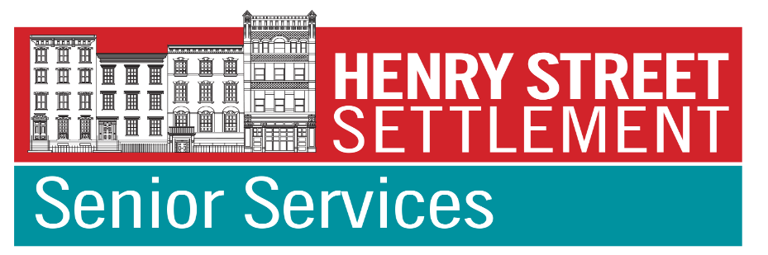 |  | Coming Soon:  更多線上課程，線上報告，遊覽，旅行和表演  Funded by the NYC Department for the Aging & Henry Street Settlement |  |  | 要註冊虛擬遊覽，旅行或音樂會，  添加到我們的會員電子郵件列表中  或了解更多信息，請通過VirtualSeniorCenter@henrystreet.org與我們聯繫。或致電347-493-2787

