June 2020  Virtual Senior Center |  |  | Henry Street Settlement  Senior Center  “Where Good Friends Meet”
Monday | Tuesday | Wednesday |  | Thursday |  | Friday
11:00 am: Art w/ Jia & Ace  ZOOM CALL IN:(929) 205-6099  Zoom Mtg ID: 892 5389 0895  Click here to Join Zoom Meeting!!  12:00 pm: Noon w/ Karina  ZOOM CALL IN: (929) 205-6099  Zoom Mtg ID: 898 8824 3711  Click Here to Join Zoom Meeting!!  2:00 pm:  “The Census 2020: Why & How” w/ Jing  ZOOM CALL IN (929) 205-6099  Zoom Mtg ID: 810 6652 4506  Click Here To Join Zoom Meeting!! | 11:00 am: Salud Holística  w/ Nurse Arthur (Spanish)  ZOOM CALL IN: (929) 205-6099  Zoom Mtg ID: 820 0645 2818  Click Here To Join Zoom Meeting!!  1:00 pm: Cooking w/ Ann  ZOOM CALL IN (929) 205-6099  Zoom Mtg ID: 830 8892 0001  Click Here To Join Zoom Meeting!! | 11:00 am: Betances Health Center  ZOOM CALL IN (929) 205-6099  Zoom Mtg ID: 834 0831 7629  Click Here to Join Zoom Meeting!!  12:00 pm: Dessert w/ Ann  ZOOM CALL IN: (929) 205-6099  Zoom Mtg ID: 830 6860 7168  Click Here To Join Zoom Meeting!!  1:00 pm:  Simply Tai Chi w/David  ZOOM CALL IN (929) 205-6099  Zoom Mtg ID: 895 2337 9243  Click Here To Join Zoom Meeting!!  2:00 pm:  Be Flexible w/ Linda  ZOOM CALL IN (929) 205-6099  Zoom Mtg ID: 858 7274 2853  Click Here To Join Zoom Meeting!! |  | 1:00 pm: Pet Visiting w/ Amy,  Rexi & Whitney  ZOOM CALL IN (929) 205-6099  Zoom Mtg ID: 810 7727 0496  Click Here To Join Zoom Meeting!!  2:00 pm: Drawing w/ Will  ZOOM CALL IN (929) 205-6099  Zoom Mtg ID: 812 1135 0510  Click Here To Join Zoom Meeting!!  3:00 pm Holistic Health  w/ Nurse Arthur (Spanish)  ZOOM CALL IN (929) 205-6099  Zoom Mtg ID: 898 6066 4161  Click Here To Join Zoom Meeting!!  4:00 pm: Chinese Dancing  w/Yulan  ZOOM CALL IN (929) 205-6099  Zoom Mtg ID: 816 6732 6275  Click Here To Join Zoom Class!! |  | 11:00 am:  Your Health w/ Nurse Nicole  ZOOM CALL IN (929) 205-6099  Zoom Mtg ID: 833 2175 5297  Click Here To Join Zoom Meeting!!  12:00pm: Meditation w/Daniela  ZOOM CALL IN (929) 205-6099  Zoom Mtg ID: 867 7027 8089  Click Here to Join Zoom Meeting!!  1:00 pm: Zumba w/ Dream  ZOOM CALL IN (929) 205-6099  Zoom Mtg ID: 869 1395 7452  Click Here To Join Zoom Meeting!!  2:00 pm: Chinese Dance  w/ Dream  ZOOM CALL IN (929) 205-6099  Zoom Mtg ID: 837 4715 4778  Click Here To Join Zoom Meeting!!
 | SPECIAL EVENT!!  6/9 at 3:00pm  Virtual Trip: Brooklyn Botanical Garden W/Olivia  Zoom Mtg ID: 831 5055 6425  ZOOM CALL IN (929) 205-6099  Click Here to Join Zoom Meeting!! | 2:00 pm:  Be Flexible w/ Linda  ZOOM CALL IN (929) 205-6099  Zoom Mtg ID: 858 7274 2853  Click Here To Join Zoom Meeting!!  3:00 pm: Art w/ Linda  ZOOM CALL IN (929) 205-6099  Zoom Mtg ID: 819 7461 2024  Click Here To Join Zoom Meeting!! |  | SPECIAL EVENT!!  6/18 11:00 am: “Vocal Ease”  Telephone-Concert  Must pre-register via e-mail at virtualseniorcenter@henrystreet .org  SPECIAL EVENT!!  6/25 3:00 pm  Senior Center Birthday Celebration  w/ Oliva  ZOOM CALL IN (929) 205-6099  Zoom Mtg ID: 884 2701 8730  Click Here to Join Zoom Meeting!! |  | 2:00 pm: Chinese Dance  w/ Dream  ZOOM CALL IN (929) 205-6099  Zoom Mtg ID: 837 4715 4778  Click Here To Join Zoom Meeting!!  SPECIAL EVENT!!  6/12 11:00 am  Lilian Wald Museum Tour  @ Henry Street Settlement Headquarters  ZOOM CALL IN (929) 205-6099  Zoom Mtg ID: 812 4538 0377  Click Here to Join Zoom Meeting!!
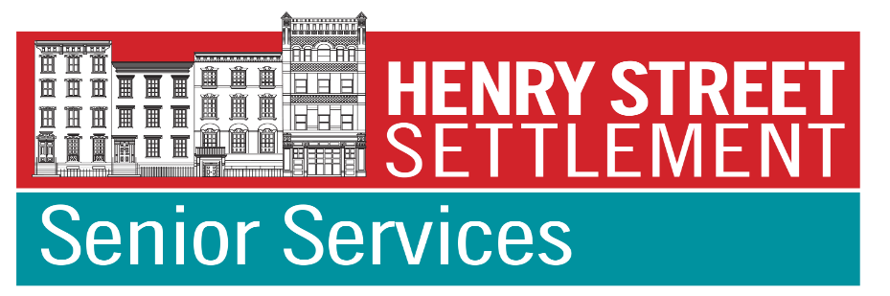 |  | Coming Soon:  More Virtual Classes  Plus Virtual Presentations, Trips, Tours & Performances |  |  | To register for virtual tours, trips or concerts,  be added to our member email list  or for more information, please contact us at VirtualSeniorCenter@henrystreet.org  or call 347-493-2787

