 |  | 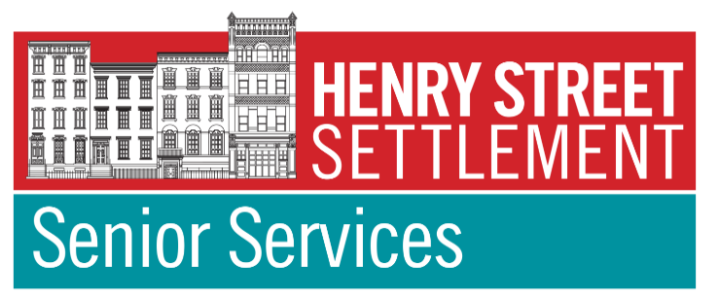  
We are now on YouTube, click link  below and subscribe to our channel to get the latest updates and events!  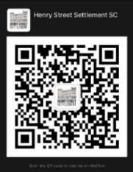  YOUTUBE - CLICK HERE!!  We are now also on  WeChat. Simply  download the App on  your smartphone and  scan the QR code to add us!  Follow and Like us on Facebook –  www.facebook.com/HenryStreetSettlement | PRESENTATIONS:  1:00pm: Curiosity Stream w/ Olivia “The Science of Sleep”  8/12  Zoom Mtg ID: 958 4584 2951  Click Here to Join Zoom Class!!  1:00pm: Curiosity Stream w/Olivia “The Truth About Healthy Eating”  8/19  Zoom Mtg ID: 944 2345 7269  Click Here to Join Zoom Class!!  TRIVIA/GAMES:  3:00pm: Trivia w/ Olivia (win prizes)  8/20  Zoom Mtg ID: 973 3136 9054  Click Here to Join Zoom Class!!  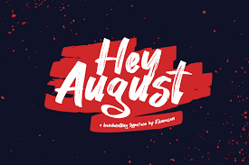 | PARTIES / CELEBRATIONS:  3:00pm: Birthday Party  w/ Olivia 8/26  Zoom Mtg ID: 884 2701 8730  Click Here to Join Zoom Class!!  VIRTUAL TOURS:  1:00pm: Harry Potter Studio Tour  in London w/ Olivia 8/9  Zoom Mtg ID: 936 5832 5466  Click Here to Join Zoom Class!!  1:00pm: Beautiful National Parks  in USA w/ Olivia 8/16  Zoom Mtg ID: 993 1427 1087  Click Here to Join Zoom Class!!  12:00pm: 9/11 Memorial Museum  w/ Olivia 8/17  Zoom Mtg ID: 998 8565 7171  Click Here to Join Zoom Class!! | To register for virtual tours, trips or concerts, added to our member email list to receive our monthly calendar & early notice of special programming,  or for more information, please contact us at  VirtualSeniorCenter@henrystreet.org  or call 347-493-2787
Funded by the  NYC Department for the Aging,  Henry Street Settlement &  Your Contributions |  |  | Do you live in the Vladeck Houses  and need some help or support?  Call our NORC/ Vladeck Cares Office at 212-477-0455.  Our office are now open  Monday - Friday 10 AM - 4 PM  By Appointment Only.
Admit You're Happy Month
Family Fun Month
Dog Days of Summer - July 3 - August 11
International Pirate Month
National Catfish Month
National Eye Exam Month
National Golf Month
National Picnic Month
Peach Month
Romance Awareness Month

AUGUST Virtual Calendar 2021
Activities with an * are Vladeck Cares/NORC- & New York State Office for the Aging (NYSOFA)-Funded
All Other Programming & Services are Funded by the New York City Department for the Aging (DFTA), Henry Street Settlement and YOUR Contributions
Monday | Tuesday | Wednesday |  | Thursday | Friday
National Ice cream sandwich Day 8/2  1:00pm: Bingo w/ Olivia  Zoom Mtg ID: 874 8318 1329  Click Here To Join Zoom Class!!  VIRTUAL TOURS:  1:00pm: Harry Potter Studio  Tour in London w/ Olivia 8/9  Zoom Mtg ID: 936 5832 5466  Click Here to Join Zoom Class!!  1:00pm: Beautiful National  Parks in USA w/ Olivia 8/16  Zoom Mtg ID: 993 1427 1087  Click Here to Join Zoom Class!! | National Chocolate Chip Day 8/4  12:00pm: “Farmers Market  Workshops” w/ EatingHealthyNYC  Zoom Mtg ID: 871 7219 6163    Click Here To Join Zoom Class!!  2:00pm: “What You Should  Know About Alzheimer’s”  by AFA / Alzheimer’s  Foundation of America  Zoom Mtg ID: 821 2118 6861  Click Here To Join Zoom Class!!  12:00pm: 9/11 Memorial  Museum NYC w/ Olivia 8/17  Zoom Mtg ID: 812 8573 4070  Click Here to Join Zoom Class!! | International Cat Day 8/8  EVENT:  11:00 am: Meditation  w/ Threejewels.org  Zoom Mtg ID: 966 9790 2710  Click Here to Join Zoom Class!!  1:00 pm: Simply Tai Chi w/  David  Zoom Mtg ID: 895 2337 9243  Click Here To Join Zoom Class!!  2:00 pm: Be Flexible w/ Linda  Zoom Mtg ID: 858 7274 2853  Click Here To Join Zoom Class!! |  | Senior Citizen 8/21  4:00pm: Chinese Dance Rehearsal  Zoom Mtg ID: 816 6732 6275  Click Here To Join Zoom Class!!  VIRTUAL CONCERT:  11:00am: Vocal Ease 8/12  Robo Call Concert  (Non-Zoom Participants, please  register in advance via  email or by phone)  PARTIES:  3:00pm: Senior Birthday Party  w/ Olivia 8/26  Zoom Mtg ID: 884 2701 8730  Click Here to Join Zoom Class!!  PRESENTATIONS:  1:00pm: Curiosity Stream “The  Science of Sleep” w/ Olivia 8/12  Zoom Mtg ID: 898 8824 3711  Click Here to Join Zoom Class!!  1:00pm: Curiosity Stream “The  Truth About Healthy Eating”  w/ Olivia 8/19  Zoom Mtg ID: 944 2345 7269  Click Here to Join Zoom Class!! | National Kiss and make up Day 8/31  10:00am: Zumba w/ Jiali  Zoom Mtg ID: 869 1395 7452  Click Here To Join Zoom Class!!  11:00am: Chinese Dance w/  Jiali  Zoom Mtg ID: 837 4715 4778  Click Here To Join Zoom Class!!  12:00pm: Yoga  w/ Three Jewels.org  Zoom Mtg ID: 921 7367 9797  Click Here to Join Zoom Class!!  CONCERTS:  3:00pm: “Music Concert”  8/6, 8/13, & 8/27  Zoom Mtg: 834 9178 9152  Click Here To Join Zoom Class!!  TRIVIA/GAMES:  3:00pm: Trivia w/Olivia  (win prizes) 8/20  Zoom Mtg ID: 973 3136 9054  Click Here to Join Zoom Class!!
AUGUST ON-SITE Calendar 2021
We are excited to announce we have been approved by the  NYC Department for the Aging to reopen the Henry Street Settlement Senior Center for limited capacity programming,  Grab-and-Go Meals.  Meals will be distributed between 12pm and 1pm outside 356 Madison Street (Courtyard), New York, NY 10002. All meals are prepared in-house by our chef.  HSS Senior Center indoor dining are allowed in the rear dining room with limited capacity. Please bring your white DFTA BAR CODE key tag with you so that we can easily check you in for attendance. In the event you need a new bar code key tag, our Case Managers will be able to assist you.  Please wear a mask and practice social distancing when you arrive to pick up your meal. Please social distance when you dine-in. Mask are required at all times inside the Senior Center for programming.  We hope to continue to expand our classes and meal services, please stay tuned for more details. If you have any questions, please call us at 212-349-2770.  We missed you and we look forward to welcoming you back at Henry Street Settlement Senior Center! |  |  | We are now open Monday – Friday from  9:00am - 5:00pm  If you have any questions, we can be reached at  212-349-2770.  We have the following activities available in person with limited capacity:  - Grab & Go Meals: available from 12:00pm - 1:00pm  - Billiards (Pool Table): in the rear dining room  - Meet & Greet: Come in and catch up with your friends in our conversation circle setup (limited 6 people per circle)  - Computer Room: (limited 4 people at a time)  - Computer Class w/ Caroline: (learn how to use  computer) 8/2-8/13 from 2:00-3:00pm  - Social Services: Walk-in/Appointment  - Tai Chi for Arthritis w/ Anne Moss: Every Thursdays  from 10:30am-11:30am. Last class 8/19  - Karaoke: Every Tuesdays and Fridays 2:30pm-4:30pm  - Beaded Arts w/ Mary: Every Tuesdays  1:00pm-2:00pm  - Linda Move It Move It- Every Thursdays  1:00pm- 2:00pm  - Art w/ Linda: Every Thursdays  2:00pm- 3:00pm  - Gym: Monday to Friday 9:00am – 11:00am  Monday to Friday 1:30pm to 3:30pm  - Presentation: “Nutrition” by VNSNY  Monday 8/16 from 10:30am -11:45am  - Ping Pong: Monday through Friday 9:00am to 4:45pm
Sign up as a new member or renew your membership today and refer a friend to become our member for a chance to win the raffle. A $50 Gift Card! We will select 3 winners one in each category.
Winners will be announced on October 1st 2021.

