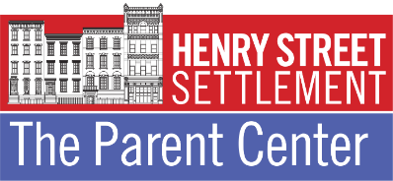

**JULY 2022 PARENT CENTER WORKSHOPS**

**During the month of July, Henry Street Settlement’s Parent Center will offer 1-time workshops on a range of parenting topics (see below) online at Zoom, facilitated by Parent Center licensed social work and mental health staff. See workshop topics and Zoom registration links below.**

**All workshops are FREE and open to the public.**

**NOTE:** Workshops are held online via ZOOM video conferencing. Participants need to access the ZOOM App on their phone, computer, or other device to participate. For more information about how to download and use Zoom, click [here](https://www.youtube.com/watch?v=fVu9BILRkww). Workshops require pre-registration. Please see topics, dates, times and registration links below. After registering, you will receive a confirmation email containing information about joining the Zoom meeting. Participants requesting a Parenting Workshop Certificate will need to arrive no later than 15 minutes after the start of the workshop. For more information and/or if you have additional questions, please call 212.471.2400, x. 1813 or email [ParentCenter@HenryStreet.org](mailto:ParentCenter@HenryStreet.org).

_____________________________________________________________________________________________

**Time Management:**This workshop will provide ways you can manage time and create effective routines and schedules for you and your family.  
**Workshop Facilitator: Qiqi Liang, LMHC  
When: Wednesday, July 6th at 11AM EST** [**Click HERE to Register**](https://us06web.zoom.us/meeting/register/tZYtceuurTksHNeemyMyPokzjweb53M9TyJ2)  
  
**Engaging Children Through Play and Creativity:** Learn about the value of play, and creative ways you can facilitate play and learning in your home.  
**Workshop Facilitator: Tera M. Gurney, LCSW**   
**When: Thursday, July 7th at 10AM EST** [**Click HERE to Register**](https://us06web.zoom.us/meeting/register/tZckf-usqD4iGNJewGJ7zAOdS9B2mcdGqOHo)  
  
**有效的教养方式和技巧** **(Effective Discipline Techniques—for Chinese Speakers):**  
此讲座面向各个年龄段孩子的家长，重点讲教养方式与技巧、以及如何表达对孩子的爱.  
**Workshop Facilitator: Qiqi Liang, LMHC**   
**When: Wednesday, July 13th at 11AM EST** [**Click HERE to Register**](https://us06web.zoom.us/meeting/register/tZwkceytqTIqH9COaohyfSnwyksLNQt1wUEv)  
   
**Encouraging Healthy Relationships in Children + Teens:** Gain an understanding of healthy vs. unhealthy relationships and how you can encourage healthy relationships for your children.  
**Workshop Facilitator: Tera M. Gurney, LCSW**   
**When: Thursday, July 14th at 10AM EST** [**Click HERE to Register**](https://us06web.zoom.us/meeting/register/tZUtdOygqD4tGdIvuDaL9fz151_76zgosC6w)  
 

**Successful Co-Parenting:** This workshop will discuss the importance of successful co-parenting, how parents can establish a healthy co-parenting relationship and help their children adjust.   
**Workshop Facilitator: Qiqi Liang, LMHC**   
**When: Wednesday, July 20th at 11AM EST** [**Click HERE to Register**](https://us06web.zoom.us/meeting/register/tZEvcOCoqTkjH9IlirJQjlN7vO6fF2CzWxfO)  
  
**Understanding Mental Health:** This workshop will briefly review a range of definitions and contributing factors regarding mental health in children and adults, with a focus on stigma, barriers to care, and how to support children and others.  
**Workshop Facilitator: Tera M. Gurney, LCSW**   
**When: Thursday, July 21st at 10AM EST** [**Click HERE to Register**](https://us06web.zoom.us/meeting/register/tZ0tdOmrpz4jGdOP0sW9P_zjyuIpf-j-pkfn)  
  
**Helping Young Children Self-Regulate + Cope with Emotions:** Together we will review techniques you can use to teach your young child about emotions, and how to regulate and cope with strong emotions in the moment.  
**Workshop Facilitator: Tera M. Gurney, LCSW**   
**When: Thursday, July 28th at 10AM EST** [**Click HERE to Register**](https://us06web.zoom.us/meeting/register/tZMpc-6gqT0rH93zBWo9BPXKu-7sO7VxhbzF)

**ABOUT OUR PARENT CENTER WORKSHOP FACILITATORS**

**Parent Center Workshop Facilitator Ms. Tera Gurney, LCSW** is a Licensed Clinical Social Worker with over ten years of professional experience in the field of parenting education, mental health and treatment of survivors of sexual violence. She served as Parent Center Social Worker/Program Coordinator from 2014-2017 and has since developed a wide range of family-centered trainings to support healthy child and family development. Tera has presented at national conferences including the Chicagoland Title IX Consortium Conference and National Association of Social Workers Illinois Statewide Conference. She is the proud mother of two young sons.

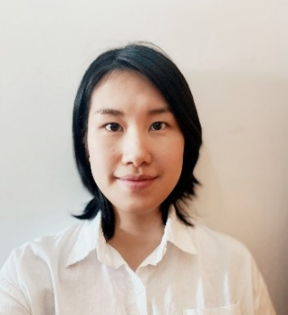**Parent Center Mental Health Counselor Ms. Qiqi Liang, MHC-LP** is a bilingual Mental Health Counselor fluent in Chinese including Mandarin and Cantonese dialects. She completed her MA Degree in Mental Health Counseling at the Nyack College Alliance Graduate School of Counseling (AGSC). Prior to joining the Parent Center Team in 2020, she conducted intakes and facilitated supportive counseling groups at Henry Street Settlement’s Community Consultation Center in the PROS Program.

**Parent Center Social Worker Ms. Annie Mudick, MA, MSW** is a graduate of the NYU and Sarah Lawrence Dual Degree program. She holds an MA Degree in Child Development and MSW in Social Work. Annie has a number of years of experience working with children ages 0-7 and families in a variety of contexts, including pre-schools, summer camps, and behavioral health/mental health clinics. Her expertise spans from clinical work with children diagnosed with ODD, ADD/ADHD, and autism-spectrum disorders, to families participating in Early Head Start programs and more. Annie graduated from Tufts University with a BA Degree in Child Development and Clinical Psychology.