

**OCTOBER 2024 PARENT CENTER WORKSHOPS**

**During the month of October, Henry Street Settlement’s Parent Center will offer 1-time workshops on a range of parenting topics online at Zoom, facilitated by Parent Center licensed social work and mental health staff. See topics and Zoom registration links below.**

**All workshops are FREE and open to the public.**

**NOTE:** Workshops are held online via ZOOM. Participants need to access the ZOOM App on their phone, computer, or other device to participate. For more information about how to download and use Zoom, click [here](https://www.youtube.com/watch?v=fVu9BILRkww). Workshops require pre-registration. Please see topics, dates, times and registration links below. After registering, you will receive a confirmation email containing information about joining the Zoom meeting. Participants requesting a Parenting Workshop Certificate will need to arrive no later than 15 minutes after the start of the workshop. For more information please call 212.471.2400, x1831 or email [ParentCenter@HenryStreet.org](mailto:ParentCenter@HenryStreet.org).

_____________________________________________________________________________________________

**Taking Care of YOU: Self-Care Reminders for New Parents**

New parents often face unexpected stressors and challenges and so this workshop will explore ways parents can care for themselves while also caring for newborns, infants, toddlers and young children.

**Workshop Facilitator: Mary Beth Spaulding, MSW**

**When: Thursday October 3, 2024 – 2:00pm**

[**CLICK HERE TO REGISTER**!](https://henrystreet-org.zoom.us/meeting/register/tZcpcO2trzktHNfZKgPWORac-l2sbz0-4FfW)

**What is Therapy?** Provides information on different therapeutic modalities and what to consider when choosing a therapist for you or your child.

**Workshop Facilitator: Annie Mudick, MA, LMSW**

**When: Friday, October 4th at 1 PM EST**

[**CLICK HERE TO REGISTER!**](https://henrystreet-org.zoom.us/meeting/register/tZUkceCsrjwiHNOgCM0R1Do3aNIfRTtsP3KX)

**Special Education: What Parents Need to Know:** This workshop provides a brief overview of the Special Education process in New York City, including specific guidelines that parents should be aware of, and ways they can advocate for themselves and their family.

**Workshop Facilitator: Mary Beth Spaulding, MSW**

**When: Thursday, October 10th at 3:00 PM EST**

[**CLICK HERE TO REGISTER!**](https://henrystreet-org.zoom.us/meeting/register/tZwrd-GoqzgpHtwg2_R7IUyczSp-VsbDpahV)

**Single Parenting:** Provides information on how to support your mental health as a single parent, strategies to parent better, and ways to look for outside support.  
**Workshop Facilitator: Mary Beth Spaulding, MSW**   
**When: Thursday, October 17th at 3:00 PM EST**

[**CLICK HERE TO REGISTER!**](https://henrystreet-org.zoom.us/meeting/register/tZckduuppzgrG9Hvp_eNFAFx2S3rZjWiuB5G)

**Internet Safety for Parents of Children and Teens:** This workshop will focus on what children and teens are doing online and ways to protect your family, understand cyberbullying and its prevention, and more.

**Workshop Facilitator: Annie Mudick, LMSW**

**When: Friday, October 18th at 1 PM EST**

[**CLICK HERE TO REGISTER**](https://henrystreet-org.zoom.us/meeting/register/tZUpf-msrjsqHtBXXD_XsJOs35VerOIG5jUV)

**Executive Functioning:** This workshop will help explain what executive functioning is and provide tips for both caregivers and children to help maximize organization, time management, and follow-through with tasks.

**Workshop Facilitator: Mary Beth Spaulding, MSW**

**When: Thursday, October 24th at 3:00 PM EST**

[**CLICK HERE TO REGISTER!**](https://henrystreet-org.zoom.us/meeting/register/tZYudO-tpzkjGNTikvun0xlYC420gjqAjy3v)

**Talking to Kids About Gender Identity and Sexuality:** Learn terms and other information related to gender identity and sexuality and ways to talk about these areas.

**Workshop Facilitator: Annie Mudick, LMSW**

**When: Friday, October 25th at 1 PM EST**

[**CLICK HERE TO REGISTER**](https://henrystreet-org.zoom.us/meeting/register/tZMocO6qqDIpHNZGmGeXqLfVqF7VsfosxWA3)

**ABOUT OUR PARENT CENTER WORKSHOP FACILITATORS**

**Parent Center Social Worker Ms. Annie Mudick, MA, LMSW** is a graduate of the NYU and Sarah Lawrence Dual Degree program and received her Master’s Degree in Child Development and Social Work. Annie has years of experience working with children and families in a variety of contexts, such as preschools, summer camps, and behavioral clinics. She also has experience working with children ages 0 to 7 who are diagnosed with ODD, ADHD, and/or Autism, as well as families participating in Head Start programs. She has Bachelor’s degrees from Tufts University in Child Development and Clinical Psychology, and is originally from Phoenix, Arizona.

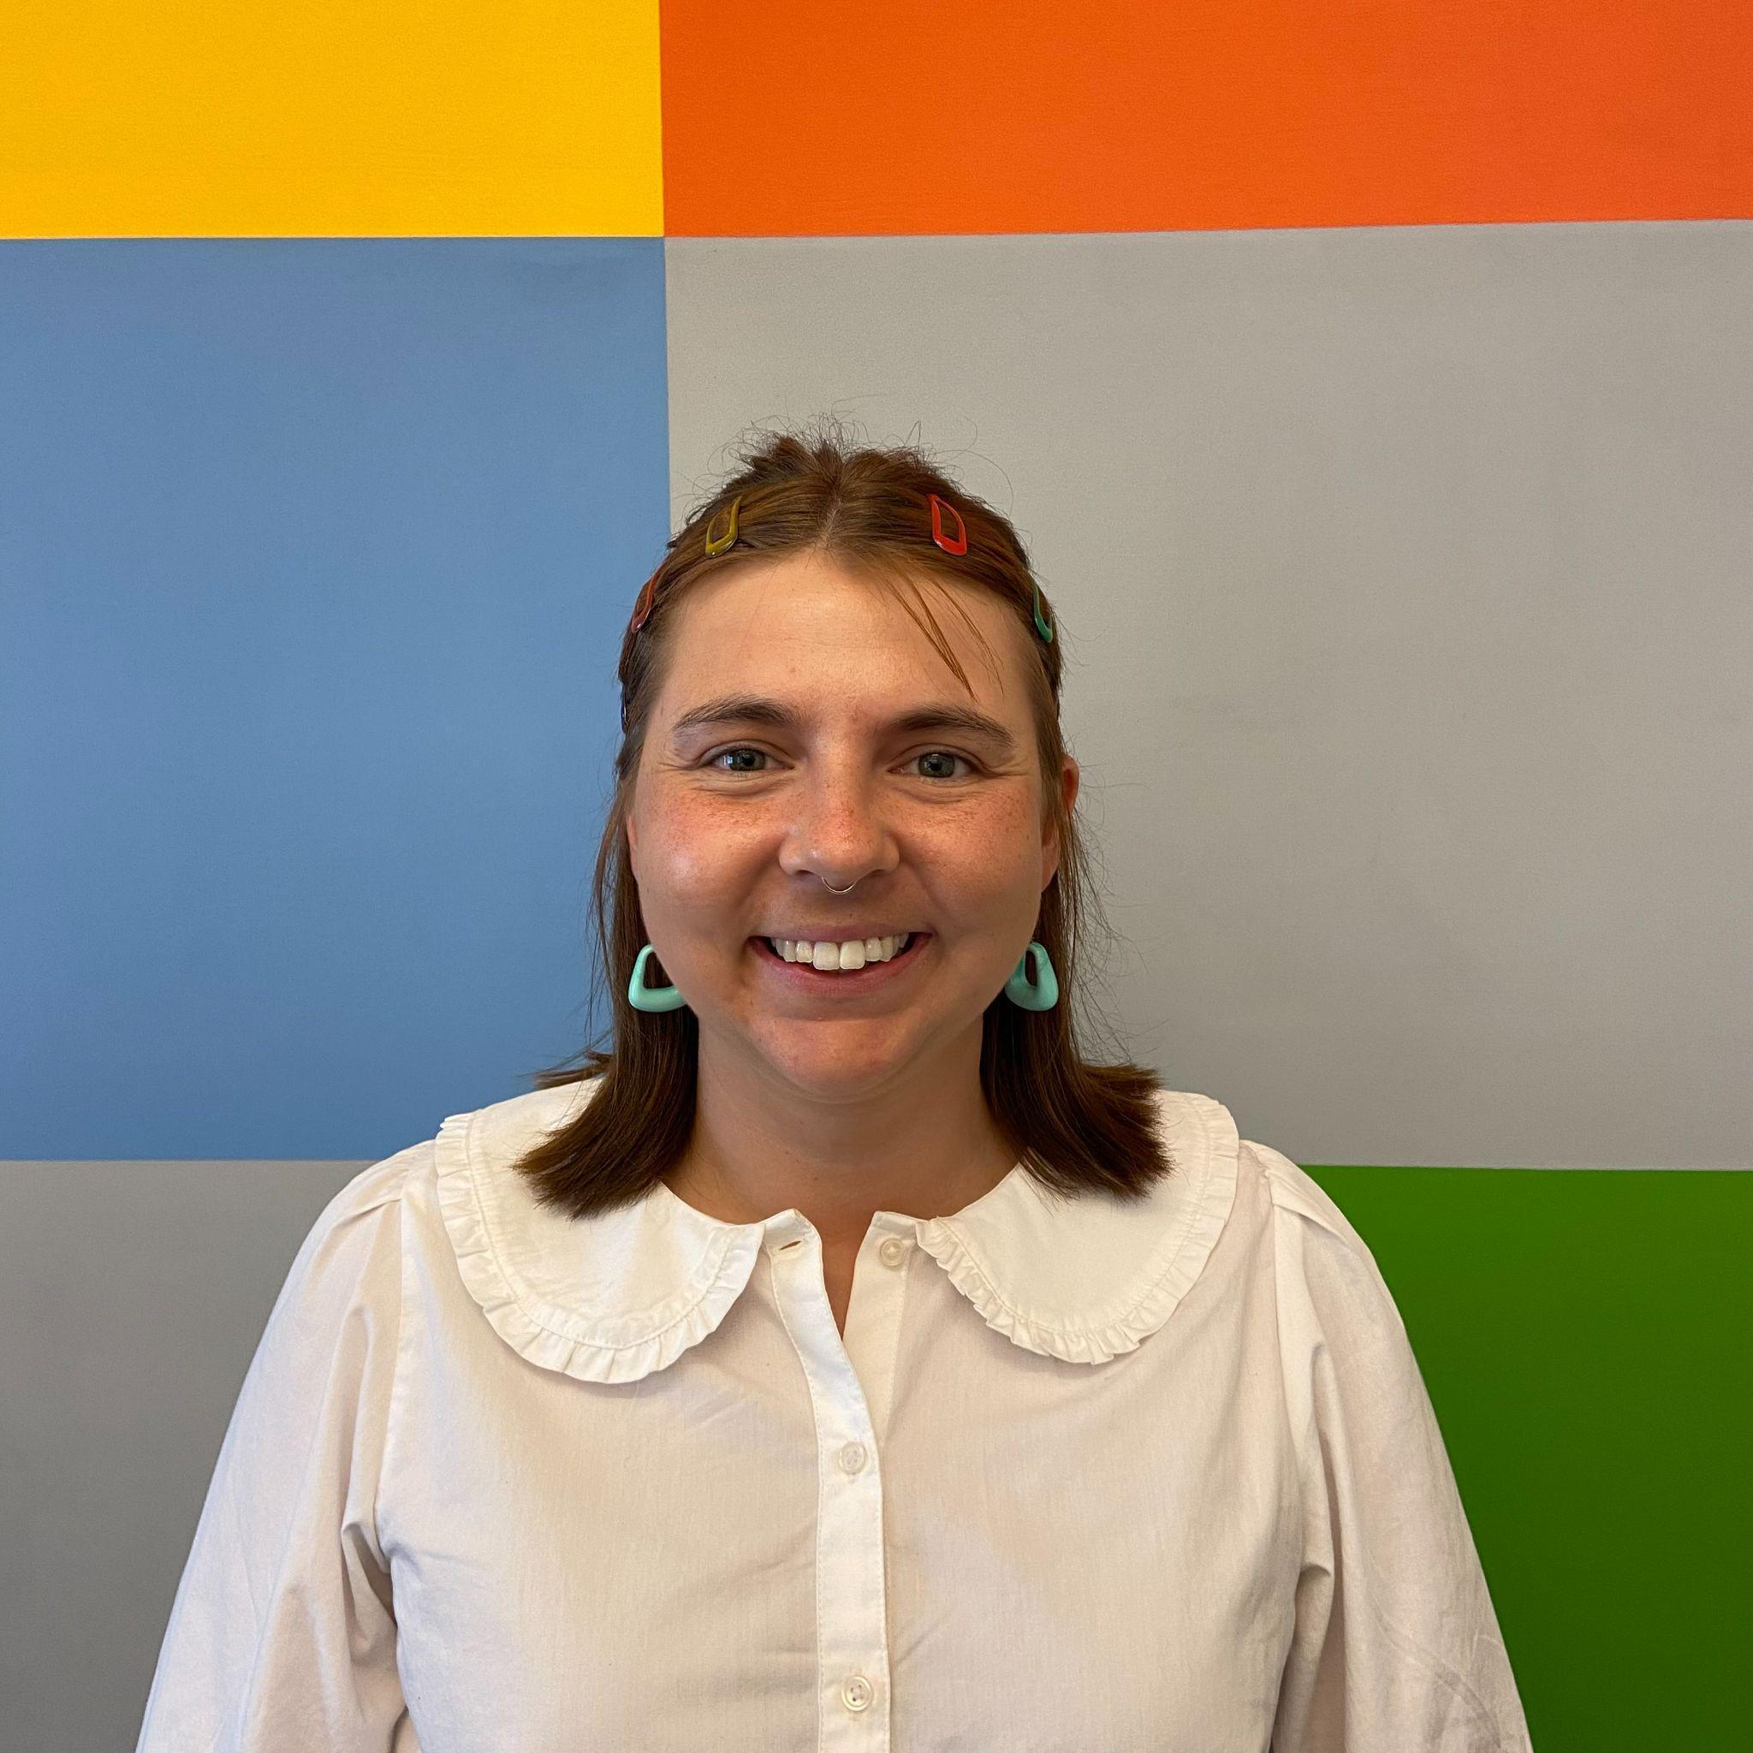

**Parent Center Social Worker Ms. Mary Beth Spaulding, MSW** Is a graduate of the Silberman School of Social Work at Hunter College. Prior to enrolling at HSSW, Mary Beth worked at Henry Street Settlement’s Urban Family Center where she connected families to case management resources, provided supportive counseling, and led parenting groups. Mary Beth has experience working with individuals coping with mental health issues, survivors of domestic violence, and children of all ages who have experienced trauma. She has a Bachelor’s degree in social work from the University of Kentucky.